**CARESTREAM HEALTH**

Revision History

|  |  |  |
| --- | --- | --- |
| **Revision** | **Description of Change** | **Revision date** |
| 0.1 | Initial version | 2016-11-17 |
|  |  |  |

**TABLE OF CONTENTS**

1 Introduction 2

2 Test Environment 2

3 Test Strategy 2

3.1 Test Object 2

3.2 Test type 2

3.3 PS Transactions analysis 3

3.4 CS Transactions analysis 3

3.5 Test Tool 3

3.6 Background data 4

4 Test scenario 4

4.1 PS Performance 4

4.2 PS Reliability 4

4.3 CS Performance 4

4.4 CS Reliability 5

5 Test Scope 5

5.1 In Scope 5

5.2 Out Scope 5

6 Risk 5

7 Schedule 6

# Introduction

The PUMA performance and reliability testing works will focus on the Print Server of Kiosk (PS) and Central server of WeChat system (CS).

The new version PS system will integrated with other 3rd systems like HIS, RIS, LIS. System will synchronize 3rd party data and provide the report print services. The CS system will integrated with PS and WeChat platform and provide the message notice, information query and other functions.

We should confirm the performance of system will meet the requirement and real work environments.

# Test Environment

The detailed hardware configurations of all servers are described as follow:

|  |  |  |  |  |  |
| --- | --- | --- | --- | --- | --- |
| **Computer name** | **CPU** | **Memory** | **HD** | **OS** | **Comments** |
| PS Server | Intel i7-2600 3.4GHz | 6GB | 1TB | Windows 2012 R2 64bit |  |
| Workstation Server1 | Intel i3-2120 3.3GHz | 8GB | 1TB | Windows 2008 R2 SP1 64bit |  |
| Workstation Server2 | Intel i3-2120 3.3GHz | 8GB | 1TB | Windows 2008 R2 SP1 64bit |  |
| Workstation Server3 | Intel i7-860 2.8GHz | 8GB | 1TB | Windows 2008 R2 SP1 64bit |  |
| Terminal | Intel Atom D525 1.8GHz | 4GB | 450GB | Windows Embedded Standard SP1 64bit |  |
| CS Server | Ali Cloud server | TBD | TBD | TBD |  |

Table 1 Hardware Configuration

# Test Strategy

## Test Object

PUMA system integrated with PS and CS system. So we will do the performance and reliability testing work for PS and CS independent.

First, we will focus on the PS system performance testing work. We will simulate the webservice call and send them to PS server and monitor the transactions response time, service performance and hardware resource usage. This scenario will include the 3rd request, report achieved, film and report print and synchronize service transactions etc.

Second, we will do the same works for CS system but the transactions should meet the requirements for CS. The focus transaction will be data synchronize, message notice and other functions.

## Test type

Performance test:

Focus on the performance and hardware usage. To confirm the response time meet the requirements and no hardware or software usage risk.

Reliability test:

Focus on the reliability and transaction veracity. The workflow should work well on durational scenario.

## PS Transactions analysis

1. Create treatment: Create the patient treatment in HIS.
2. Create Order: Create patient order in HIS.
3. Create Requests: Create requests with order type automatically in HIS.
4. User payment: Patient pays the payment in HIS.
5. Exam status update: Create the exam in 3rd party system such as RIS, LIS and etc.
6. Report status update: Create or update the report status for patient reports.
7. Terminal report print: Patients print all type reports.

The main workflow follows the step1 to step7. We will design the automation scripts to simulate the patient operations for the testing work.

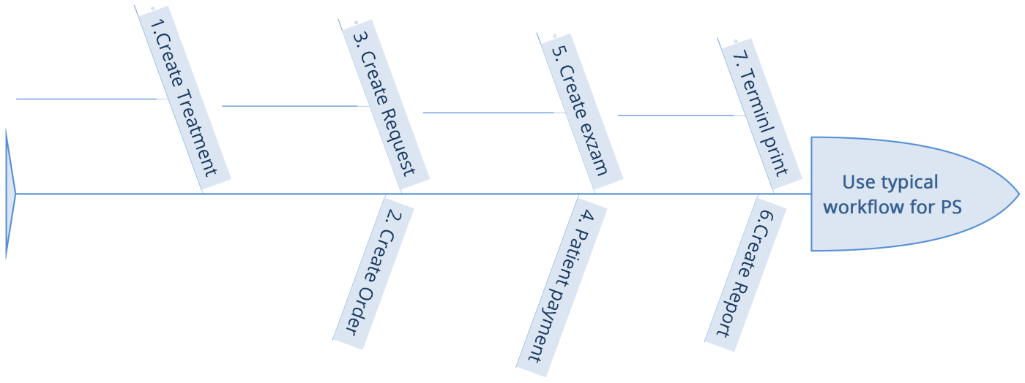

Figure3.3.1

## CS Transactions analysis

1. Synchronize data: Synchronize the data come from PS such as the transaction as the step1-step7 in PS transaction lists.
2. Print WeChat 2dcode label: Print the labels from 3rd party system.
3. Query film/report status: Query status from CS system.
4. Query treatment status: Query status from CS system.
5. Query reservation status: Query status from CS system.
6. Send status change notification: Send the change notification message for status change.
7. Send reservation reminder notification: Send the message for reminder notification.
8. Scan to print: Scan the label and try to print the film and reports.

The main workflow is trigger the status changed in PS system and CS will send the notifications and several query operations. We will design the automation scripts to simulate the system operations.

## Test Tool

Loadrunner 12, Jmeter or SoapUI.

We need to do some invested work for test tool and decide use which one for our testing works.

## Background data

We will simulate 50,000 records in the PS and CS system as background data. These data can add by automation scripts, test tool or SQL script.

# Test scenario

## PS Performance

Virtual User: 50 Users

Duration: 2 hour

Description: Use the test tool simulates the patient operations. Monitor the server software and hardware resource usage. The detail information as follow:

1. 5 virtual users simulate terminal print operations.
2. 45 virtual users simulate the typical patient`s workflow in chapter 3.4.
3. 3 virtual users simulate doctors to send film and report to PS by using QTP script.
4. Monitor the server hardware resource usage (CPU, memory and etc).
5. Monitor the server software resource (IIS, service and etc).
6. Monitor the database usage and performance index (Lock, waits and etc).
7. Each virtual user starts the next iteration after it finish current iteration with 5 seconds think time.

## PS Reliability

Virtual User: 50 Users

Duration: 12 hour

Description: Use the test tool simulates the patient operations. Monitor the server software and hardware resource usage. The detail information as follow:

1. 5 virtual users simulate terminal print operations.
2. 45 virtual users simulate the typical patient`s workflow in chapter 3.3.
3. 3 virtual users simulate doctors to send film and report to PS by using QTP script.
4. Monitor the server hardware resource usage (CPU, memory and etc).
5. Monitor the server software resource (IIS, service and etc).
6. Monitor the database usage and performance index (Lock, waits and etc).
7. Each virtual user starts the next iteration after it finish current iteration with 3-5 minutes think time randomly.

## CS Performance

Virtual User: 50 Users

Duration: 2 hour

Description: Use the test tool simulates the patient operations. Monitor the server software and hardware resource usage. The detail information as follow:

1. 5 virtual users simulate terminal print operations.
2. 45 virtual users simulate the typical patient`s workflow in chapter 3.4.
3. 3 virtual users simulate doctors to send film and report to PS by using QAP script.
4. Monitor the server hardware resource usage (CPU, memory and etc).
5. Monitor the server software resource (IIS, service and etc).
6. Monitor the database usage and performance index (Lock, waits and etc).
7. Each virtual user starts the next iteration after it finish current iteration with 5 seconds think time.

## CS Reliability

Virtual User: 50 Users

Duration: 12 hour

Description: Use the test tool simulates the patient operations. Monitor the server software and hardware resource usage. The detail information as follow:

1. 5 virtual users simulate terminal print operations.
2. 45 virtual users simulate the typical patient`s workflow in chapter 3.4.
3. 3 virtual users simulate doctors to send film and report to PS by using QAP script.
4. Monitor the server hardware resource usage (CPU, memory and etc).
5. Monitor the server software resource (IIS, service and etc).
6. Monitor the database usage and performance index (Lock, waits and etc).
7. Each virtual user starts the next iteration after it finish current iteration with 3-5 minutes think time randomly.

# Test Scope

## In Scope

1. Plan and report writing work.
2. Prepare test data, design scripts and scenario, execute test cases and result collect.
3. Monitor the software and hardware resource usage information.
4. Bottleneck identification and tuning suggestion include the software and hardware.

## Out Scope

1. Code-level bottleneck tuning.
2. Other transactions which do not define in plan.
3. 3rd party system performance and reliability testing work.

# Risk

1. Need more time to indentify the test tool meet the test requirements or not.
2. QA need more time resource to familiar the APIs for PUMA in order to design the test scripts.
3. QA Team needs more time to prepare the background test data with tool.
4. The 3rd party system is not the real customer environment. The API performance will affect the performance of PUMA.
5. Any requirements or code design change.

# Schedule

|  |  |  |  |  |  |
| --- | --- | --- | --- | --- | --- |
| **No** | **Content** | **Begin** | **End** | **Assigner** | **Remark** |
| 1 | Test plan design and review | 2016-11-17 |  | Ralf Wang | 5 |
| 2 | Test environment set up |  |  |  | 5 |
| 3 | Prepare the test background test data |  |  |  | 5 |
| 4 | Design the test scripts. |  |  |  | 30 |
| 5 | Design the test scenario. |  |  |  | 5 |
| 6 | First round of performance test for PS |  |  |  | 3 |
| 7 | First round of reliability test for PS |  |  |  | 3 |
| 8 | Performance optimization & verification |  |  |  | 3 |
| 9 | First round of performance test for CS |  |  |  | 3 |
| 10 | First round of reliability test for CS |  |  |  | 3 |
| 11 | Performance optimization & verification |  |  |  | 3 |

Describe the overall verification and validation testing objectives.

Please make appropriate modifications to the sample text so it accurately reflects this project.

**<End of Document>**